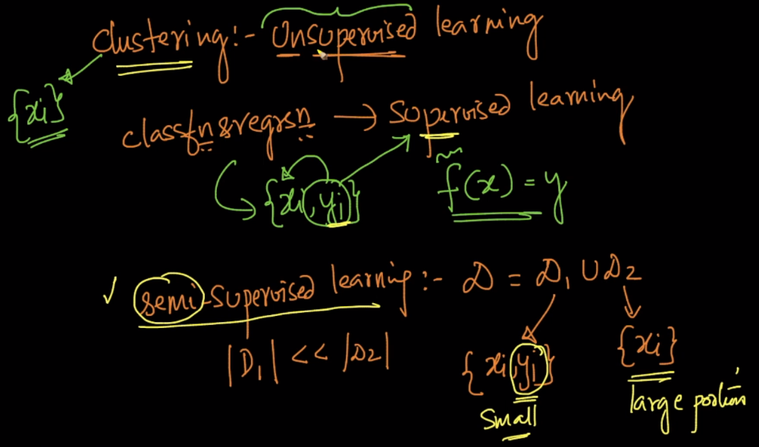

Classification and regression where we are given output along with data points are said to be supervised learning schmes, because here output is supervising the learning.

Now as we know in clustering, there is no output to supervise the learning therefore it’s called unsupervised.

There is also a category of semi-supervised, where the dataset is the union of 2 dataset, in first there is x along with y and in second there is only x, so because there is y only in first and it’s forming composition of both, it’s called semi supervised algo.

